WO Snapshot Dashboard
Instructions by: Avery Briggs
Date 2021-09-17

This button is found in Access in SysproCompanyA.
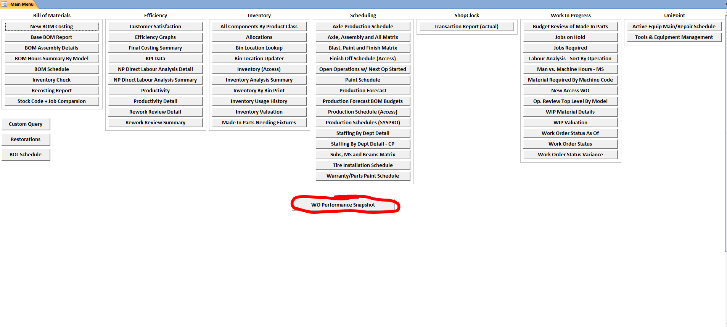
Next you will be taken to the input menu:
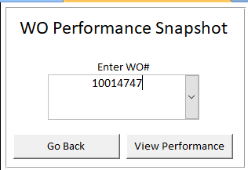
You may enter a 10 million, 20 million or 70 million job number in this input box.

If you enter a 20 million or 70 million number, you will be navigated to a dynamic subs report. This only reports values where the work-center was marked as “S”.
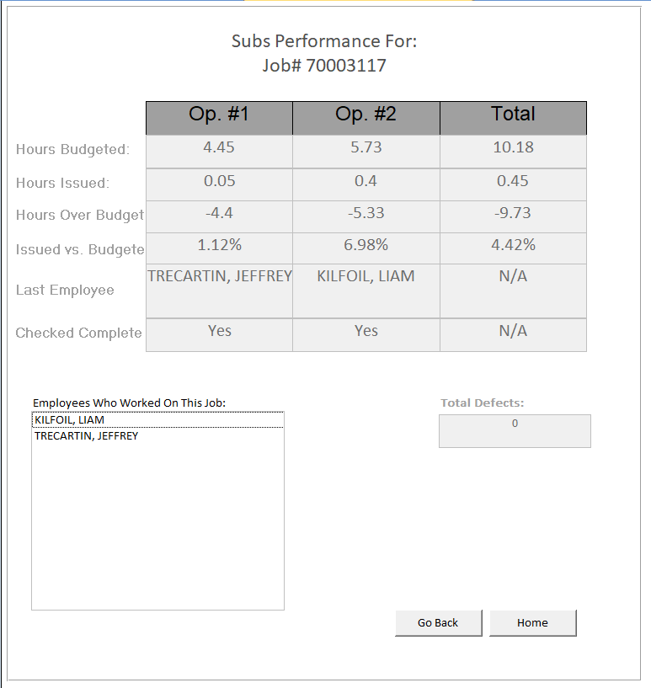

If you enter a 10 million number you will be navigated to a different form showing only data from operations 4 and 5.
